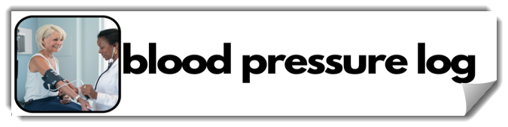
Date | Time | Blood Pressure |  | Date | Time | Blood Pressure
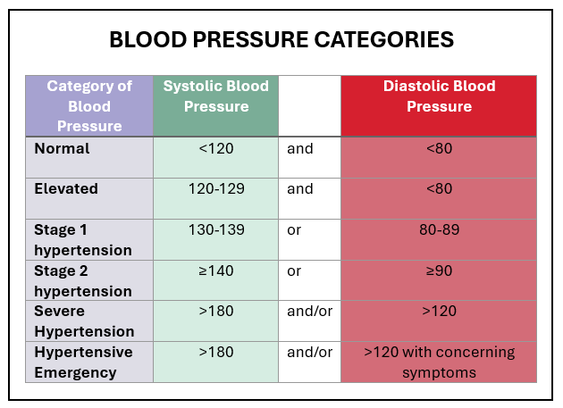 | Table is based on the American Heart Association Blood Pressure Categories.  If you have severe hypertension and no symptoms, call your healthcare professional.  If you have severe hypertension and chest pain, shortness of breath, back pain, weakness, problems speaking, vision changes, numbness or any other concerning symptoms, call 911 immediately.

